RAM KUMAR SINGH
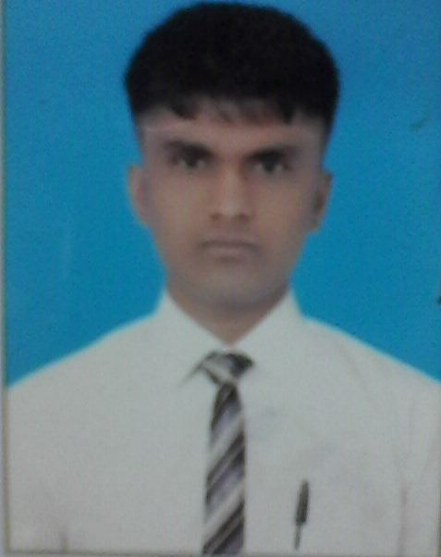
Electrical Design Engineer.
Saluja CAD Consultancy Services.
B.E. Electrical (E&P).
R.T.M. University, Nagpur.
A-559, New Ashok Nagar.
New Delhi-110096.
Mobile: +91-9175408595
Email id: ramsing47@gmail.com
RESUME

CARRIER OBJECTIVE
Seeking for an Employee in your company to enhance my skills and to contribute the best of my knowledge and experience in achieving organizational goals and personal growth.
PROFESSIONAL EXPERIENCE.

- Total Experience- 2 years

1- AUGUST-2016 to till now SALUZA CAD CONSULTANCY . Gurgaon, working as an Electrical Design engineer.

SALUZA CAD CONSULTANCY is a design oriented organization, they work on all types of Electrical Mechanical and Civil projects from various company according to their requirements and specifications, like fixture ,electrical towers and plant layout designing as well as building projects etc.

Responsibilities:-
- Design 2D/3D drawing in AutoCAD as per dimensions.
- Generation / drafting of all drawings, Control Schematic Diagram, Power Diagram,
- Designing site layouts (module layout, wiring, civil, stringing etc.) of solar power projects.
- Equipment placement, foundation & elevation arrangements in plants.
- Development of new plant layout concepts.
- Development of new concepts in designing.
- Continuous implementation of design improvements.
- Planning & modeling of equipment, piping and supports in 3D CAD.
- Preparation of detailed drawings for Sub Station Layout, Power Layout / Lighting layout / Cable tray & Trench layout.
- Load Calculation & Selection of DG, Transformer & Capacitor Capacity, along with all relevant calculations such as short circuit current & selection of components.
- Calculation of voltage drops, Estimation of cable length and selection of proper size cables.
Single Line Diagram, Terminal Detail, Interlocking etc.
- Preparation of lighting drawing on dialux.
- Assessment of technical specifications during designing phase
- Preparing Project Completion Report (D.B.R) and case-studies.
- Preparation of BOM, Preparation of Cables Schedule, Cables Specification, Cables Data Sheets & Cables BOQ. & Project Costing.
- Coordination with Architect, Consultant, vendors and Civil wing along with site visits.
- Documentation & compile of design.
- Provide trustworthy feedback to the management

2-JANUARY 2016 TO AUGUST-2016 working as a full time Apprentice trainee in IHG GROUP.

Responsibilities:-
 
- Overall responsibility of shift activities which includes attending electrical breakdowns, performing preventive maintenance, critical motors inspection and preparing shift reports.
- Ability to successfully manage multiple priorities and assignments.
- Building Facilities Management/BMS & FCS Operations
- Inspection and monitoring of 1.8MVA 440 V , 3 Phase Diesel Generator sets .
- All Type of Compressors (Centrifugal, Screw, Reciprocating) Work.
- Maintenance & Troubleshooting of HT/LT, AC/DC Motors, DOL Starters, Soft Starters.
- Knowledge in Electrical distribution system.
EDUCATIONAL QUALIFICATION
QUALIFICATION | BOARD/UNIVERSITY | SCHOOL/COLLEGE | PASSING YEAR | %MARKS
B.E | NAGPUR UNIVERSITY | P.I.E.T | 2015 | 58.17%
12TH MATH'S | B.S.E.B. PATNA | M.S COLLEGE, MOTIHARI | 2011 | 58.60%
MATRICULATION | B.S.E.B. PATNA | HIGH SCHOOL,CHANPATIA | 2009 | 60.40%

SOFTWARE COURSES & TRAINING
- AutoCAD 2D & 3D.
- MS office package.
- Successfully completed 6 days vocational training at Electric loco shed Ajani Nagpur
- Power Plant familiarization workshop.

ACADMIC PROJECT
- Project Title:-Hybridization Of Solar & Wind Energy System
- Project Description-This System Generates Energy, By Using Both Solar& Wind but Gives Constant Single Output at a time.

PERSONAL DETAILS
Name -Ram Kumar Singh
Date of Birth -20th February 1994
Father’s name -Jagdish Singh.
Nationality - Indian.
Marital Status - Unmarried.
Education - B.E. From RTM University Nagpur
Languages Known-English, Hindi & Panjabi
Permanent Address-At-Lachhnouta, P.O-Dhamoura, P.S-Sathi, Dist.-West Champaran.-845449 Bihar (INDIA)
Driving license no -BR2220120025884
PASSPORT NO- M8595743
Email Id. -ramsing47@gmail.com
DECLARATION
I do hereby inform that all the above information furnished by me is true and completed to the best of my knowledge and belief.

Place :DELHI RAM KUMAR SINGH

